Tel: +256 789084004
+256 781242684
+ 256-770736311
shineafricaministries@gmail.com/
safteso@gmail.com
https://safteso.netlify.app/
Plot1-7 Olio Avenue Old Mbale Road Red Cross
Building
P. O. Box 684, Soroti Uganda, E. Africa

SAF-Teso
Shine Africa Foundation -Teso
“Empowerment through sustainable community led interventions in the Teso Sub-Region.”

PERIOD COVERED: 1st August 2022 to 30th June 2023
TYPE OF REPORT: PROGRESS MID-GRANT REPORT

PROJECT TITLE: SCALING UP HIV AND TB SERVICES IN SOROTI AND SERERE DISTRICTS.
CONTACT INFORMATION: (EXECUTIVE DIRECTOR, PROGRAM OFFICER AND FINANCE).
Name: Anguria Michael  Title: Executive Director  Email: shineafricaministries @gmail.com  Tel. No: 0781242684  Signature: 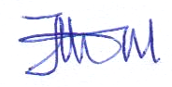 | Name: Apio Sharon  Title: Program officer (HTS F/P)  Email.apiosharon4004@gmail.comTel. No: 0789084004  Signature: | Name: Amuge Grace  Title: Accountant  Email: safteso@gmail.com  Tel. No: 0787 812280  Signature:

EXECUTIVE SUMMARY
SAF-TESO is implementing HIV/TB control and prevention project in Soroti and Serere districts, Eastern Uganda. SAF-TESO is supporting 11 health facilities of Serere health center IV, Asuret HC III, Aarapo health Centre III, Oburin health Centre HC III and Kagwara health Centre III in Serere District, Kichinjaji Health Centre III, Tubur Health Centre III, Tiriri Health Centre III, Soroti Regional referral hospital and Uganda cares in Soroti District. The project aims to contribute to a reduction in HIV and TB incidence among the general population focusing mostly on key and priority populations including adolescents, youth and young women in Soroti and Serere district through increasing access to utilization of high impact HIV prevention interventions. And supporting on the provision of life saving care and treatment to people living with HIV by supporting retention of clients to care and treatment, providing intensive adherence counseling to clients with non-suppressed viral loads, reducing GBV incidences and TB prevalence rates among PLHIV and ensuring linkage and referrals in the supported health facilities.
SAF-TESO worked with the health facility team, village health teams, peer leaders, expert clients, and people living with HIV, Mentor mother and YAPs
This activity report covers the period of 1st August 2022 to 30th June 2023 end of project implementation.

The summary of key achievements in the reporting period is as per set objectives below:
- To increase Prevention of new HIV infections and TB in Soroti and Serere districts by the end of June 2023.

During the project term a total of 3,360 individuals were mobilized and tested for HIV 664 through APN testing,295 through SNS testing ,170 through index client testing 1,742 during outreach for men and 452 were TB presumptive clients tested for HIV.
250 HIV positives were identified and linked to care and treatment 116 through APN testing,39 through Social network strategy testin,11 through index client testing ,64 through outreach for men and 20 were presumed TB clients who tested positive for HIV.
Since the last report, a total of 1529 individuals were mobilized and tested for HIV 175 during APN testing,159 during social network strategy testing,35 during index client testing,972 during outreach for men and 169 were presumed TB clients tested for HIV. 107 HIV positives were identified and linked to care.36 through APN testing,26 through social network strategy testing,2 through index client testing ,35 during outreaches for men testing and 8 were presumed TB clients who tested positive for HIV.
Throughout the project period, a total of 1,012 clients were tested for STI s a total of 232 were tested positive for STIs and started on treatment.
Since the last report, a total 876 individuals were tested for STI during OPD clinics at health facility 314 tested positive for STI and were started on treatment.
A total 2,774 TB contacts were screened for TB 1414 were presumed to have TB and their sputum samples were collected for TB test ,94 tested positive for TB and were started on treatment.623 clients were started on TB prevention therapy

Since the last report, 1568 clients were screened for TB ,774 were presumed to have TB and were tested,53tested positive for TB and were started on TB treatment.350 clients were started on TB prevention therapy.

- To increase linkage and referrals to health services in Soroti and Serere district by the end of June 2023
All 314 identified HIV/TB clients were linked to care. During the project term, a total of 245 HIV positives and 69 TB positive clients were linked to HIV and TB care and all started on treatment in the supported health facilities.
SAF-TESO conducted 6 radio talk shows to increase demand for HIV and TB services. This was conducted by two technical panelists. 2 monthly sensitization drives were conducted in the project catchment key populations and priority populations
A total of 820,000 Condoms were distributed to hotspots, leisure centers, lodges, bars and clinics both female and male 164,000 through Serere HC IV, 169000 through Kagwara HC III, 45,000 through Aarapo HC III, 162,000 through Soroti Regional Referral Hospital, 130,000 through Uganda cares clinic and 150,000 through Kichinjaji HC III.
Since the last report,385251 pieces of condoms were distributed 42,251 through Serere HC IV, 64,000 through Kagwara HC III, 89,000 through Aarapo HC III, 50,000 through Soroti Regional Referral Hospital, 45,000 through Uganda cares clinic and 95,000 through Kichinjaji HC III. condoms in Soroti and Serere district. This activity was conducted by peer educators and condom marketers.
- Provide access to quality care and treatment to PLHIV.
Throughout a total of 588 clients who missed appointment for ART refill were followed through home visit and phone call reminders and brought back to care during the project implementation period 405 to Serere HC IV, 92 to Kichinjaji HC III, 61 to Asuret HC III, 30 to Tubur HC III also 10 CCLADS were formed and supported to improve on retention of clients to care and treatment.
Since the last report, 181 clients who missed appointment were followed and brought back to care 159 to Serere HC IV, 31 to Kichinjaji HC III and 24 to Asuret HC III.
During project period, 269 clients with non -suppressed viral loads were followed and provided intensive adherence counselling177 for Serere HC IV ,34 from Kichinjaji HC III,44 from Asuret HC III and 14 from Tubur HC III.

Since last report,91 clients who had a non-suppressed viral load were followed and provided intensive adherence counseling.77 from Serere HC IV and 14 from Kichinjaji HC III.

Table of Contents
EXECUTIVE SUMMARY 2
Table 01: Outputs on HTS services throughout the project implementation. 6
Table 02: Out puts for the provision of HTS activities for the period of 1st march 2023 to 30th June 2023. 9
1. Table 03: Outputs to expedite the provision of antiretroviral therapy (ART) and TB treatment. 16
A) Graph on outputs on retention on antiretroviral therapy (ART) and TB treatment. 17
T.B Cascade 21
Table 04: outputs on TB 21

List of Acronyms:

AIDS Acquired Immune-deficiency Virus
APN Assisted Partner Notification
BCC Behavior Communication Change
CDC Centre for Disease Control
CSOs Civil Society Organizations
DNA Deoxyribonucleic acid
EMTCT Elimination of Mother To Child Transmission
GBV Gender Based Violence
HC Health Centre
HEI HIV Exposed Infant
HIV Human Immunodeficiency virus
HTS HIV Testing Services
KP Key Population
PCR Polymerase Chain Reaction
PMTCT Prevention of Mother To Child Transmission
SAF- TESO Shine Africa Foundation- TESO
STIs Sexually Transmitted Infections
TB Tuberculosis
Strengthen referrals and linkages between HIV/AIDS programs and CSOs

Table 01: Outputs on HTS services throughout the project implementation.
District | Name of health facility | Number of individuals mobilized and tested for HIV | Number tested through APN | HIV positives identified through APN | Number Tested through SNS testing | HIV positives identified though SNS testing | Index clients tested | Positives identified through index testing | Men 25 years and above tested for HIV | Men 25yrs and above who tested positive for HIV | TB Presumptive clients tested for HIV | TB presumptive clients who tested HIV positive
Serere | Serere HC IV | 392 | 88 | 08 | 17 | 02 | 07 | 00 | 125 | 12 | 155 | 10
 | Aarapo HC III | 331 | 48 | 12 | 66 | 08 | 26 | 01 | 77 | 07 | 114 | 06
 | Oburin HC III | 505 | 16 | 02 | 00 | 00 | 00 | 00 | 480 | 05 | 09 | 00
 | Kagwara HC III | 428 | 33 | 10 | 25 | 08 | 45 | 08 | 308 | 12 | 17 | 01
Soroti | Soroti Regional referral hospital | 458 | 82 | 27 | 42 | 09 | 11 | 01 | 292 | 01 | 00 | 00
 | Kichinjaji HC III | 263 | 138 | 13 | 74 | 09 | 00 | 00 | 51 | 05 | 00 | 00
 | Asuret HC III | 158 | 62 | 15 | 56 | 02 | 00 | 00 | 64 | 06 | 00 | 00
 | Tiriri HC IV | 169 | 42 | 05 | 00 | 00 | 00 | 00 | 67 | 04 | 49 | 02
 | Tubur HC III | 227 | 46 | 04 | 22 | 02 | 15 | 00 | 114 | 08 | 30 | 00
 | Gweri HC III | 265 | 51 | 04 | 00 | 00 | 66 | 01 | 70 | 02 | 78 | 01
 | Uganda cares | 164 | 87 | 17 | 14 | 00 | 00 | 00 | 63 | 03 | 00 | 00
Total |  | 3,360 | 664 | 116 | 295 | 39 | 170 | 11 | 1742 | 64 | 452 | 20

Summary of percentage yield.
ACTIVITY | Number tested | HIV positives identified | %yield
APN testing | 664 | 116 | 17.4%
Conducting integrated targeted outreach for men | 295 | 39 | 13.2%
Conducting social network strategy for HIV testing | 170 | 11 | 6.4%
Presumed TB clients tested for HIV | 1742 | 64 | 3.6%
Conducting index client testing | 452 | 20 | 4.4%

- The graph below summarizes out puts on provision of HTS services to date

Table 02: Out puts for the provision of HTS activities for the period of 1st march 2023 to 30th June 2023.
District | Name of health facility | Number of individuals mobilized and tested for HIV | Number tested through APN | HIV positives identified through APN | Number Tested through SNS testing | HIV positives identified though SNS testing | Index clients tested | Positives identified through index testing | Men 25 years and above tested for HIV | Men 25yrs and above who tested positive for HIV | TB Presumptive clients tested for HIV | TB presumptive clients who tested HIV positive
Serere | Serere HC IV | 171 | 28 | 02 | 17 | 02 | 00 | 00 | 44 | 06 | 82 | 03
 | Aarapo HC III | 83 | 07 | 03 | 24 | 04 | 00 | 00 | 39 | 03 | 13 | 02
 | Oburin HC III | 479 | 10 | 02 | 00 | 00 | 00 | 00 | 460 | 04 | 09 | 00
 | Kagwara HC III | 201 | 10 | 04 | 21 | 04 | 22 | 02 | 131 | 04 | 17 | 01
Soroti | Soroti Regional referral hospital | 57 | 15 | 06 | 42 | 09 | 00 | 00 | 00 | 00 | 00 | 00
 | Kichinjaji HC III | 101 | 31 | 04 | 30 | 03 | 00 | 00 | 40 | 04 | 00 | 00
 | Asuret HC III | 55 | 09 | 04 | 24 | 02 | 00 | 00 | 22 | 03 | 00 | 00
 | Tiriri HC IV | 62 | 20 | 02 | 00 | 00 | 00 | 00 | 22 | 03 | 20 | 02
 | Tubur HC III | 112 | 25 | 04 | 22 | 02 | 00 | 00 | 55 | 04 | 10 | 00
 | Gweri HC III | 106 | 10 | 01 | 00 | 00 | 13 | 00 | 65 | 02 | 18 | 00
 | Uganda cares | 102 | 39 | 04 | 00 | 00 | 00 | 00 | 63 | 03 | 00 | 00
Total |  | 1,529 | 175 | 36 | 159 | 26 | 35 | 02 | 972 | 35 | 169 | 08

a) Graph on outputs of HTS Public health facilities comparison for the months of 1st August 2022 to 30th June 2023

Achievements on HIV testing
SAF-TESO with the support of the health facility teams and community structures conducted targeted HIV testing (risk-based testing) which included index client testing (including social network testing, assisted partner testing), HIV self-testing through focused distribution of HIV self-testing kits, discordant couple testing and targeted outreaches for men 25 years and above.
In the reporting period, SAF-TESO has implemented Targeted HIV testing services which have been instrumental in identifying individuals living with HIV and linking them to appropriate care and treatment. These services aim to reach populations at higher risk of HIV infection, such as key populations, vulnerable communities, and areas with high HIV prevalence.
Targeted HIV testing services have played a pivotal role in identifying undiagnosed HIV cases, especially among populations with a higher risk of infection. By focusing on key populations, such as men who have sex with men, transgender individuals, sex workers, people who inject drugs, and incarcerated populations, these services have effectively identified individuals who may be unaware of their HIV status. Timely identification enables early access to care and treatment, reducing the risk of HIV transmission and improving health outcomes.
The provision of targeted HIV testing services has contributed to the reduction of HIV transmission rates. By identifying individuals living with HIV and linking them to treatment and support, these services have helped to suppress viral loads and reduce the risk of onward transmission. Moreover, individuals who are aware of their HIV-positive status can adopt preventive measures, such as consistent condom use, adherence to antiretroviral therapy, and engagement in harm reduction practices, thereby decreasing the likelihood of transmitting the virus to others.
Targeted HIV testing services have successfully facilitated the linkage of HIV-positive individuals to appropriate care and treatment services. By establishing referral networks, collaborating with healthcare providers, and offering on-site counseling and support, these services have improved the continuum of care. Prompt linkage to care ensures timely initiation of antiretroviral therapy, monitoring of health outcomes, and management of comorbidities, resulting in improved quality of life for those living with HIV.
In addition to testing, targeted HIV testing services have made significant contributions to raising awareness and providing health education to at-risk populations. Through counseling, workshops, and community engagement activities, these services have disseminated accurate information about HIV transmission, prevention strategies, and the importance of regular testing. By addressing stigma and discrimination associated with HIV, these services have also contributed to promoting a supportive environment for individuals living with the virus.
During the project term, a total of 3,360 individuals were mobilized and tested for HIV 664 through APN testing,295 through SNS testing ,170 through index client testing 1,742 during outreach for men and 452 were TB presumptive clients tested for HIV.
250 HIV positives were identified and linked to care and treatment 116 through APN testing,39 through Social network strategy testin,11 through index client testing ,64 through outreach for men and 20 were presumed TB clients who tested positive for HIV.
Since the last report, a total of 1529 individuals were mobilized and tested for HIV 175 during APN testing,159 during social network strategy testing,35 during index client testing,972 during outreach for men and 169 were presumed TB clients tested for HIV. 107 HIV positives were identified and linked to care.36 through APN testing,26 through social network strategy testing,2 through index client testing ,35 during outreaches for men testing and 8 were presumed TB clients who tested positive for HIV.

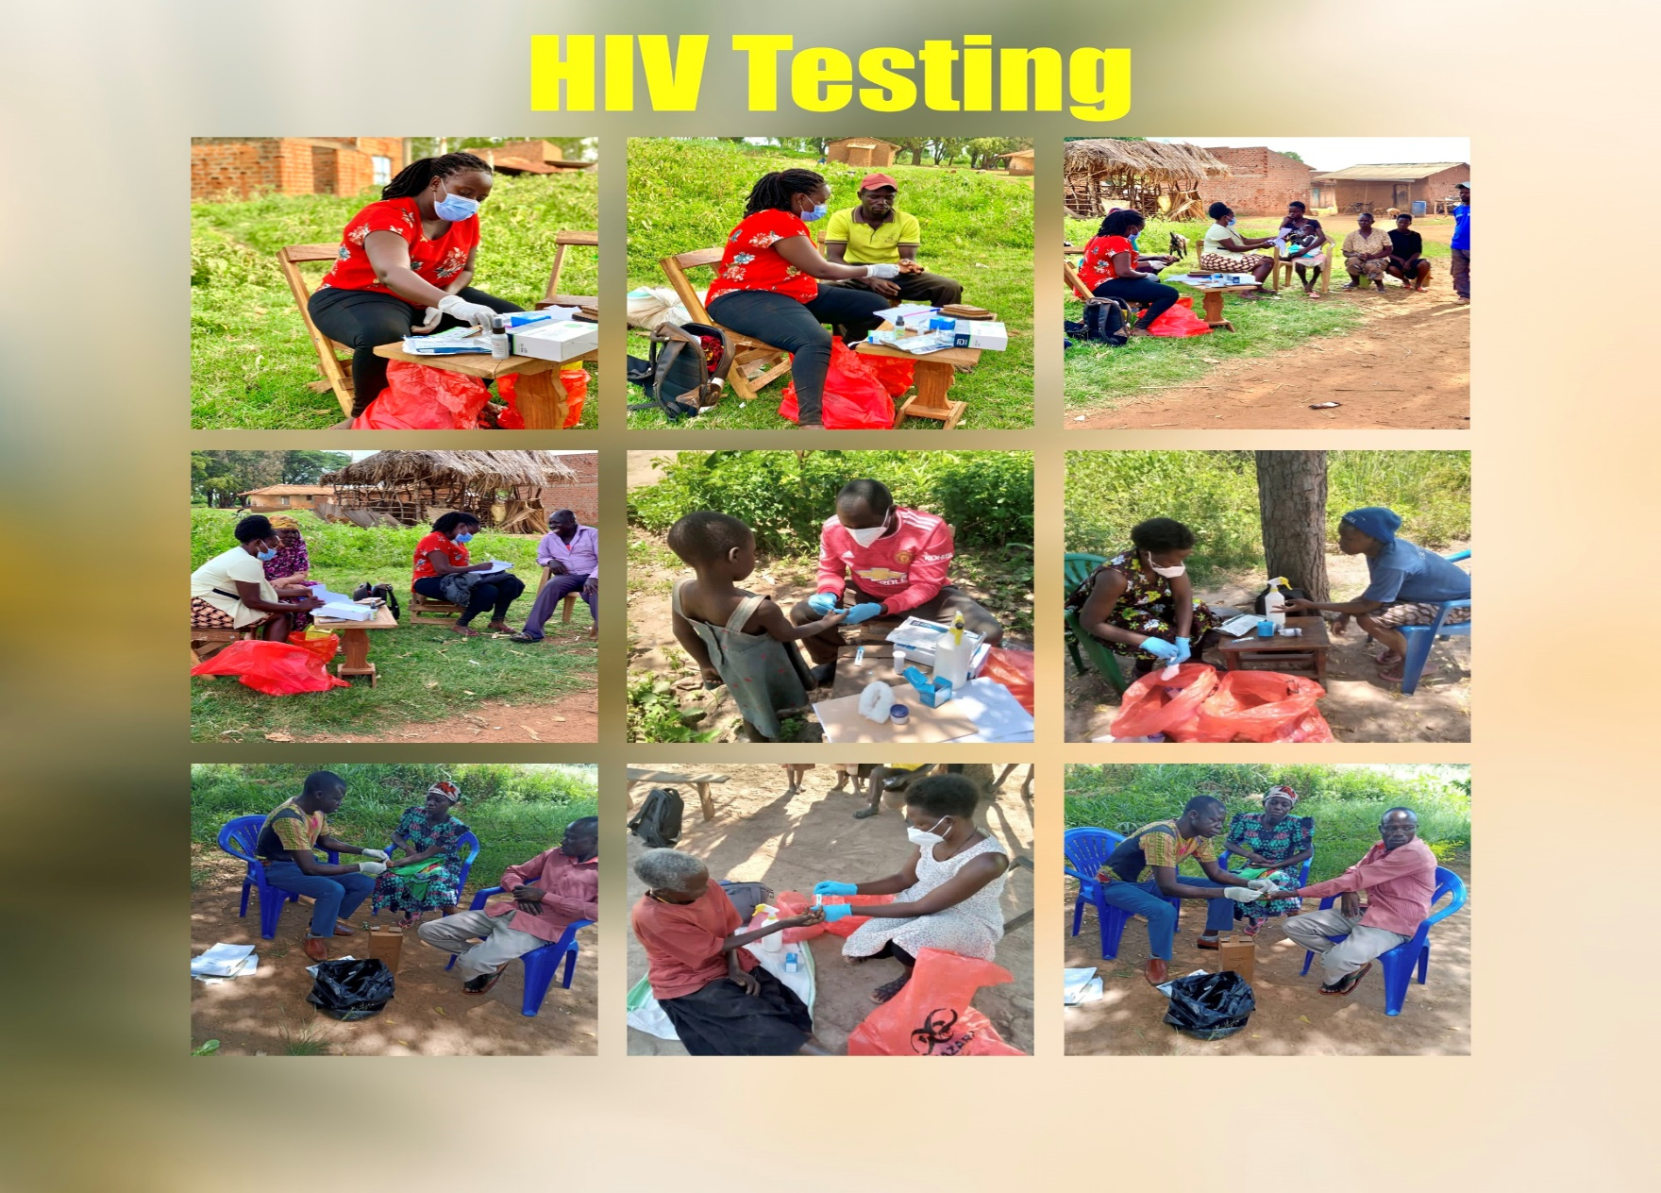
SAF-Teso and health facility teams while conducting HTS services in communities.

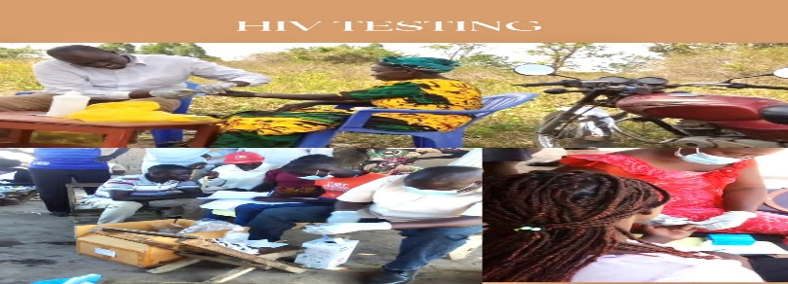
SAF-Teso and health facility teams while conducting HIV testing services in the communities.
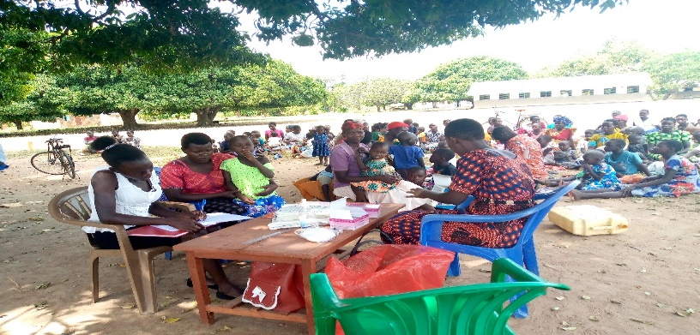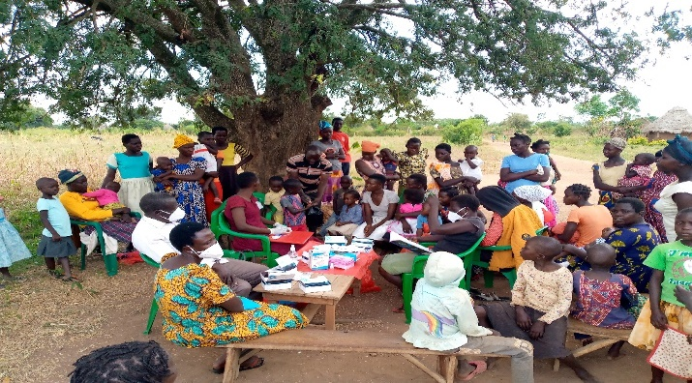
Health facility team while malaria test outreaches in communities.

Table 03: Outputs to expedite the provision of antiretroviral therapy (ART) and TB treatment.
 | Number of clients on  ART with missed followed up and brought back to care to date | No. of clients with missed appointment followed and brought back to care since last report | No. of clients on TB treatment with missed appointment followed and brought back to care to date | No. of TB clients with missed appointment followed and brought back to care since last report | No. of CCLADs and family support groups supported to date | No. followed and provide intensive adherence counseling  To date | No. followed and provide intensive adherence counseling since last report.
Serere HC III | 405 | 159 | 9 | 00 | 1 | 177 | 77
Kichinjaji HC III | 92 | 31 | 0 | 00 | 3 | 34 | 14
Asuret HC111 | 61 | 24 | 0 | 00 | 2 | 44 | 00
Tubur HC III | 30 | 00 | 0 | 00 | 2 | 14 | 00
Aarapo HC III | 00 | 00 | 24 | 00 | 1 | 00 | 00
Total | 588 | 181 | 33 | 00 | 9 | 269 | 91

Graph on outputs on retention on antiretroviral therapy (ART) and TB treatment.

Outputs on the provision of antiretroviral therapy and TB treatment
Achieving high retention and adherence rates to tuberculosis (TB) and antiretroviral therapy (ART) treatment is crucial for successful disease management and improved health outcomes.
SAF-TESO has Improved Treatment Support for clients on ART and TB by supporting the Implementation of adherence counseling services which is done by trained HIV counselors and TB focal persons to educate patients about the importance of consistent medication use, potential side effects, and strategies to overcome barriers to adherence.
We have also supported health facilities in the Identification and involvement of treatment supporters, such as family members or community health workers, who provide encouragement, reminders, and social support to patients, thereby improving adherence.
Also through Formation and support of CCLADS where patients on long-term TB or ART treatment can come together regularly to receive medication refills, share experiences, and receive counseling, fostering a sense of belonging and support
SAF-TESO during the reporting period has supported the collaborating health facilities in tracking and following up clients who are lost and those that miss appointments. using BCC to address individual, community and society barriers to retention in care. We have also established referral and linkage systems and peer led approaches in the communities to support increase access and retention in care.
A total of 588 clients who missed appointment for ART refill were followed through home visit and phone call reminders and brought back to care during the project implementation period 405 to Serere HC IV, 92 to Kichinjaji HC III, 61 to Asuret HC III, 30 to Tubur HC III also 10 CCLADS were formed and supported to improve on retention of clients to care and treatment.
Since the last report, 181 clients who missed appointment were followed and brought back to care 159 to Serere HC IV, 31 to Kichinjaji HC III and 24 to Asuret HC III.

- Outputs on Intensive Adherence counseling.
Intensive adherence counseling has significantly contributed to improved medication adherence among clients with non-suppressed viral loads. Through regular and focused counseling sessions, healthcare providers address individual barriers to adherence, provide tailored strategies, and reinforce the importance of consistent medication use. This approach has resulted in increased adherence rates and a subsequent reduction in viral loads.
SAF-TESO supported in providing Intensive counseling sessions to identify specific barriers that may hinder clients' adherence to their medication regimens. These barriers can include forgetfulness, side effects, stigma, mental health issues, substance abuse, or practical challenges. By identifying these barriers, healthcare providers can work collaboratively with clients to develop personalized solutions and interventions.
However, the main goal for the provision of intensive adherence counseling is to individualize adherence plans for clients with non-suppressed viral loads. These plans outline specific strategies and tools to support medication adherence, such as medication reminders, pill organizers, mobile applications, or involving treatment supporters. By tailoring adherence plans to the unique needs and circumstances of each client, the likelihood of sustained adherence is increased hence also enhancing treatment literacy among clients with non-suppressed viral loads. By offering comprehensive education on the importance of medication adherence, the relationship between adherence and viral suppression, and the potential consequences of non-adherence, clients gain a better understanding of the significance of consistent treatment. Improved treatment literacy empowers clients to make informed decisions and actively participate in their own care.
During project period, 269 clients with non- suppressed viral loads were followed and provided intensive adherence counselling177 for Serere HC IV ,34 from Kichinjaji HC III,44 from Asuret HC III and 14 from Tubur HC III.
Since last report,91 clients who had a non-suppressed viral load were followed and provided intensive adherence counseling.77 from Serere HC IV and 14 from Kichinjaji HC III.

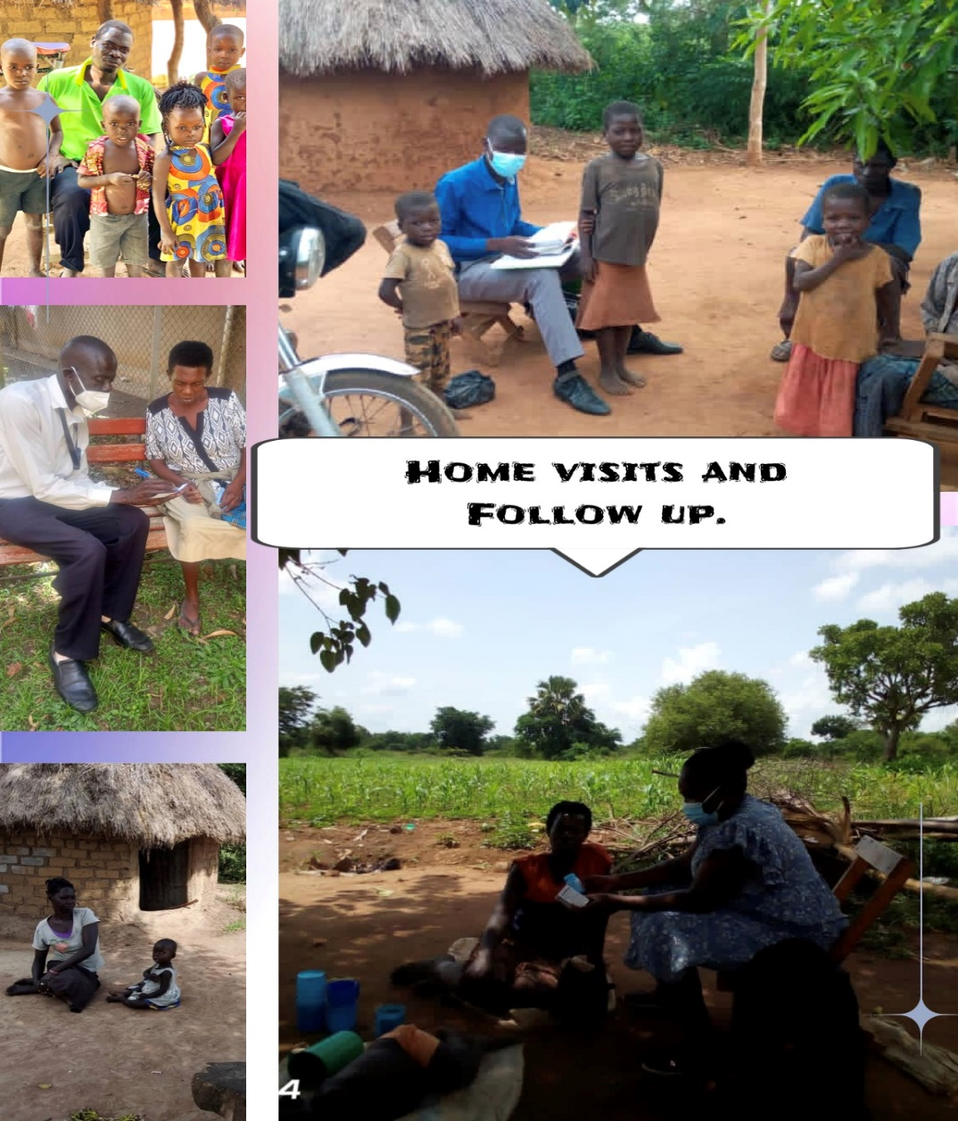

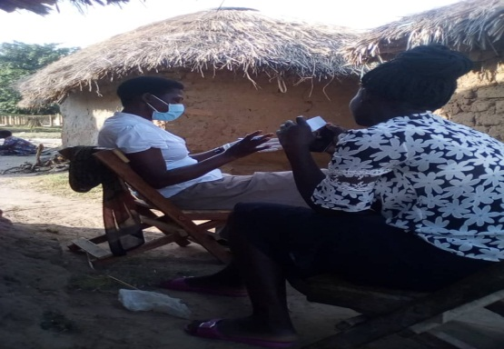
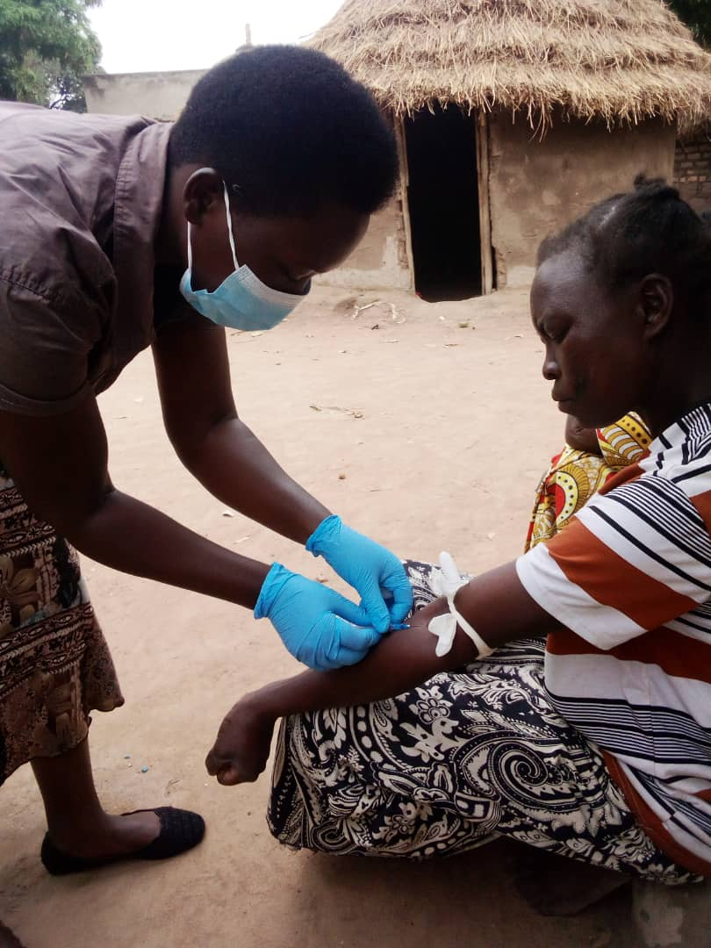
Field staff while conducting home visit follow-up for clients with missed appointment.
Health facility staff picking clients sample for VL bleeding during follow-up visit

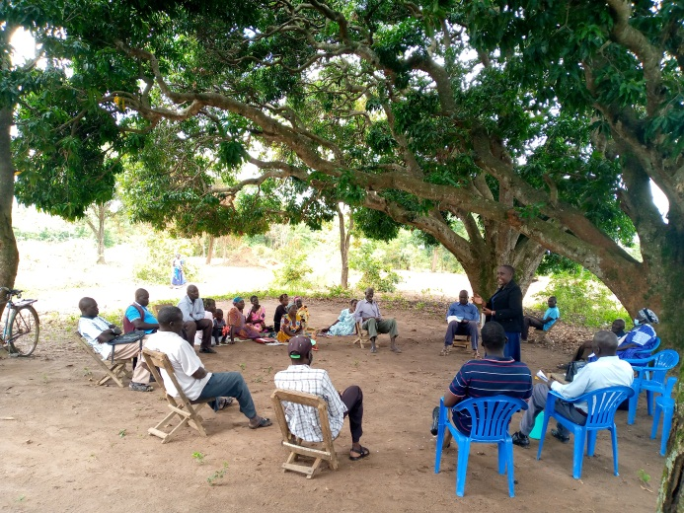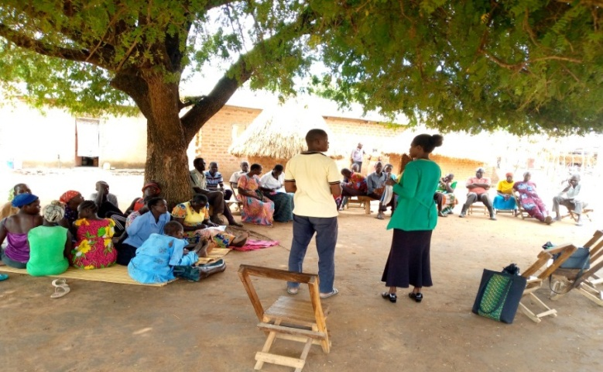
SAF-Teso team conducting CCLAD support and establishment in community.

T.B Cascade

Table 04: outputs on TB
District | Name of health facility | Number of TB contacts followed and screened for T.B in Community to date | Number of TB contacts followed and screened for TB in community since last report | No. of presumptive TB cases and tested for TB to date | Number of presumptive TB cases and tested for TB since last report. | No. of clients diagnosed with TB to date | Number of clients diagnosed with TB since last report | No of clients linked or initiated to IPT. | No. initiated to IPT since last report
Serere | Serere HC IV | 643 | 324 | 332 | 164 | 32 | 16 | 159 | 104
 | Aarapo HC III | 800 | 562 | 358 | 245 | 18 | 11 | 120 | 67
 | Kagwara HC III | 68 | 34 | 49 | 25 | 2 | 01 | 16 | 01
Soroti | Tiriri HC IV | 219 | 94 | 118 | 49 | 6 | 5 | 105 | 62
 | Gweri HC III | 356 | 177 | 209 | 98 | 24 | 11 | 95 | 45
 | Tubur HC III | 608 | 331 | 301 | 167 | 10 | 08 | 105 | 56
 | Oburin HC III | 80 | 46 | 47 | 26 | 2 | 1 | 23 | 15
Total |  | 2774 | 1568 | 1414 | 774 | 40 | 53 | 623 | 350

- The graph below summarizes out puts on outputs on TB services

During the grant period. SAF-TESO has put Efforts to expand access to TB screening, particularly in high-burden areas and vulnerable populations. Screening initiatives have been implemented in various settings but most especially through community-based outreach programs. This expansion of screening services has led to the early detection of TB cases, enabling prompt treatment initiation and reducing the risk of transmission.
SAF-TESO also conducted TB Contact tracing which has played a crucial role in identifying individuals who have been in close contact with TB patients and may be at risk of infection. Achievements in TB prevention include strengthened contact tracing efforts, utilizing advanced technologies, and improving collaboration between healthcare providers and public health departments. This has resulted in the identification of latent TB infection (LTBI) cases and the provision of preventive treatment to prevent the development of active TB disease.
We have also Increased Coverage of Preventive Therapy for individuals with latent TB infection. Preventive therapy, such as isoniazid preventive therapy (IPT), has been more widely implemented to reduce the risk of latent TB infection progressing to active TB disease. Efforts have been made to scale up the provision of preventive therapy, particularly among high-risk populations, such as people living with HIV, household contacts of TB patients, and healthcare workers.
Significant achievements in TB prevention have been made in raising public awareness and education about TB. Through advocacy campaigns, community outreach, and health education programs, individuals are informed about TB transmission, symptoms, and prevention strategies. This increased awareness contributes to early recognition of TB symptoms, prompt healthcare seeking behavior, and adoption of preventive measures, such as respiratory hygiene and infection control.
A total 2,774 TB contacts were screened for TB 1414 were presumed to have TB and their sputum samples were collected for TB test ,94 tested positive for TB and were started on treatment.623 clients were started on TB prevention therapy
Since the last report, 1568 clients were screened for TB ,774 were presumed to have TB and were tested,53tested positive for TB and were started on TB treatment.350 clients were started on TB prevention therapy.

Table 5: Sensitization and Condom distribution.
Name district | Name of supporting health facility | Number of condoms distributed  To date | Number of condoms/lubricants distributed  Since last report | Number of sensitization sessions conducted to date | Number of sensitization sessions conducted since last report
Serere | Serere HC IV | 164,000 | 42,251 | 169 | 78
 | Kagwara HC III | 169,000 | 64,000 | 130 | 76
 | Aarapo HC III | 45,000 | 89,000 | 95 | 100
Soroti | Soroti regional referral hospital | 162,000 | 50,000 | 68 | 55
 | Uganda cares | 130,000 | 45,000 | 54 | 18
 | Kichinjaji HC III | 150,000 | 95,000 | 120 | 92
Total |  | 820,000 | 385,251 | 636 | 419

- Graph showing out puts on condom distribution and sensitization sessions.

Achievements in HIV sensitization and condom distribution have played a crucial role in promoting HIV prevention and reducing the transmission of the virus. Here are some key achievements in these areas:
By conducting HIV/TB sensitization, there has been Increased Awareness and Knowledge. HIV sensitization sessions and drives have significantly contributed to increasing public awareness and knowledge about HIV/TB transmission, prevention, and the importance of safer sexual practices. Through targeted awareness programs, educational initiatives, and community engagement, individuals have become more informed about HIV/TB risks, modes of transmission, and the benefits of condom use hence decreasing in risky sexual behaviors, such as unprotected sex and multiple sexual partners. By promoting comprehensive HIV prevention messages that emphasize condom use as a key preventive measure, individuals have been empowered to make informed decisions regarding their sexual health, leading to behavior change and reduced HIV transmission.
SAF-TESO has Increased Condom Availability in various settings. Condoms are now widely accessible in healthcare facilities, community organizations, key population hotspots, leisure centers, clinics, bars/clubs, and other public places. This has increased availability ensures that individuals have easy access to condoms, reducing barriers to condom use and promoting safer sexual practices.
Condom distribution efforts have been targeted towards populations at higher risk of HIV transmission, including key populations such as sex workers, men who have sex with men, and people who inject drugs. These targeted distribution strategies have focused on reaching individuals in their own communities, establishing outreach programs, and leveraging peer networks to ensure the effective distribution and promotion of condom use.
Achievements in HIV sensitization and condom distribution have been facilitated through community engagement and peer education programs. These initiatives empower community members, including peer educators, community health workers, and local influential leaders, to raise awareness, provide accurate information, and distribute condoms within their communities. Peer education has proven to be effective in reaching marginalized populations and promoting positive behavior change.
These achievements in HIV sensitization and condom distribution have contributed to reducing HIV/TB transmission rates, empowering individuals to protect themselves, and fostering a broader understanding of HIV/TB prevention. Continued efforts in these areas, along with ongoing monitoring and evaluation, are crucial to sustaining and further advancing HIV/TB prevention initiatives.
A total of 820,000 pieces of condoms were distributed throughout the project implementation period. 164,000 through Serere HC IV, 169000 through Kagwara HC III, 45,000 through Aarapo HC III, 162,000 through Soroti Regional Referral Hospital, 130,000 through Uganda cares clinic and 150,000 through Kichinjaji HC III.
Since the last report,385251 pieces of condoms were distributed 42,251 through Serere HC IV, 64,000 through Kagwara HC III, 89,000 through Aarapo HC III, 50,000 through Soroti Regional Referral Hospital, 45,000 through Uganda cares clinic and 95,000 through Kichinjaji HC III.

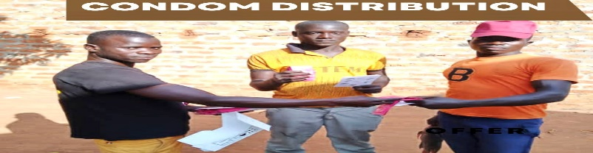
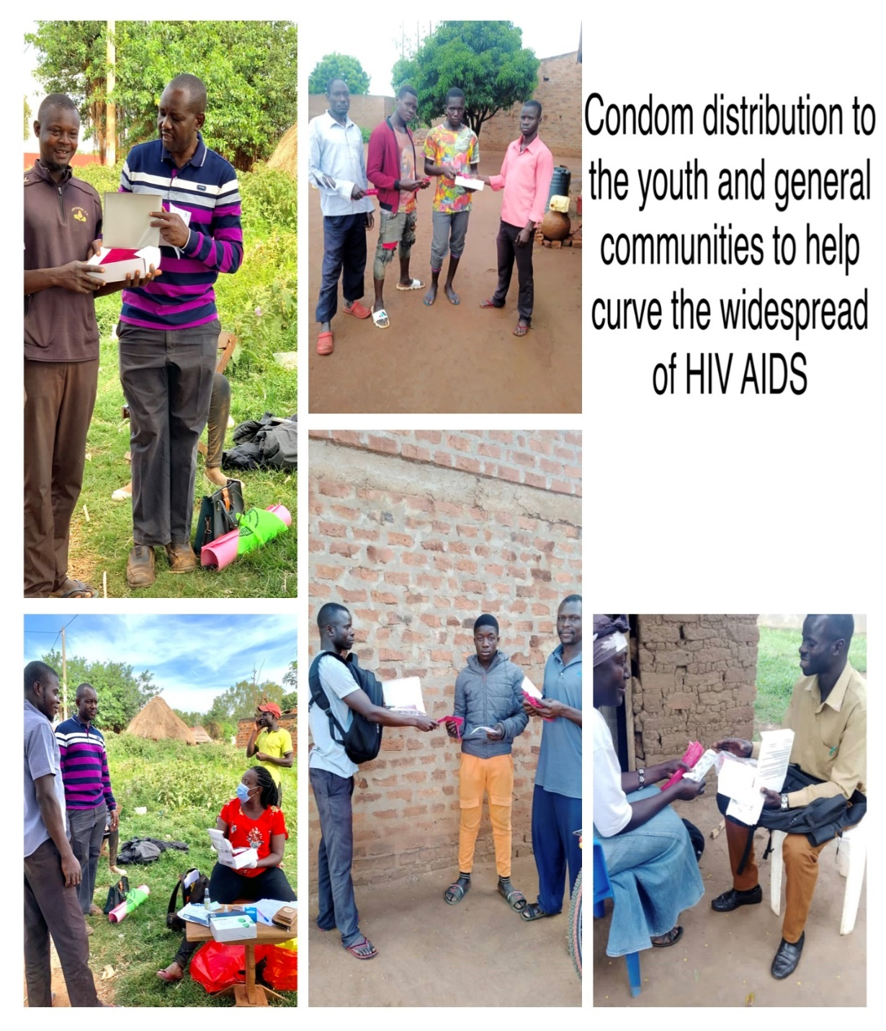
Capacity building of peer leaders on HIV/TB services (25 participants)
SAF-TESO conducted a one day capacity building training for 25 peer leaders this was done at the beginning of the project to refresh and increase the knowledge of peer leaders in HIV and TB project activity programing .topics of the training were: Behavior change communication, reduction of stigma amongst people living with HIV , HIV/TB prevention and spread ,referral systems , counseling and psychosocial support ,approaches of retention, Gender based violence ,condom distribution and availability of services for example: Prep, PEP, self -testing, family planning .the peers shared their views and challenges faced in HIV/TB project implementation.
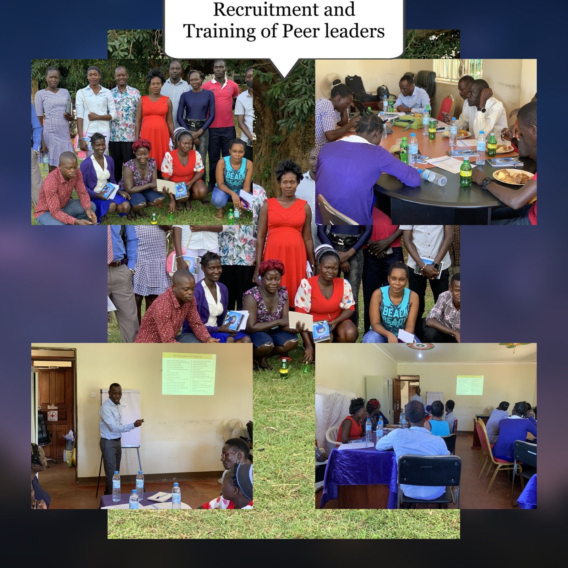
Demand creation on HIV/TB services.
Achievements in demand creation for HIV/TB services have been instrumental in increasing awareness, engagement, and utilization of HIV and TB prevention, testing, and treatment services. Here are some key achievements in the demand creation of HIV/TB services:
Demand creation involves extensive community mobilization efforts to raise awareness about the importance of HIV/TB services. Community leaders, local organizations, and healthcare providers collaborate to engage communities, disseminate information, and address misconceptions or stigmas associated with HIV/TB. These efforts create a supportive environment that encourages individuals to seek and utilize services.
Achievements involve strengthening referral systems between different healthcare facilities and community-based organizations. This ensures smooth transitions between services, facilitates timely access to testing and treatment, and optimizes the continuum of care. Robust referral systems promote coordination among providers and increase the likelihood of individuals accessing HIV/TB services.

Achievements include the integration of HIV and TB services, both within healthcare settings and at the community level. Integration improves service accessibility, reduces fragmentation, and enables individuals to receive comprehensive care for both diseases in one location. This integration also streamlines service provision, reduces duplication, and enhances efficiency.

Achievements in demand creation involve empowering key populations to advocate for their rights and access to HIV/TB services. This includes supporting the formation of community-based organizations, providing training and capacity-building opportunities, and involving key populations in the design and implementation of services. Empowering key populations ensures their active involvement in demand creation efforts, resulting in increased service utilization.

These achievements in demand creation for HIV/TB services have contributed to increased awareness, engagement, and utilization of services, leading to improved HIV/TB outcomes and reduced transmission rates. Sustaining and further expanding these efforts will be crucial to ensure continued progress in the fight against HIV and TB.

SAF-Teso conducted demand creation through monthly radio talk shows this was done monthly during the project through Etop radio station which is the most listened to radio station in Teso region. the purpose of this activity is to create awareness on HIV/TB spread, prevention and availability of access to health-related services.
Also, Community and door to door sensitization were conducted with the support of the Village health teams, peer leaders and expert clients to create awareness and increase on the demand of HIV/TB and other health services. these include HIV, family planning, HIV/TB prevention services among others.

SAF-Teso team while conducting demand through radio talk shows, sensitization drives and sensitization meetings

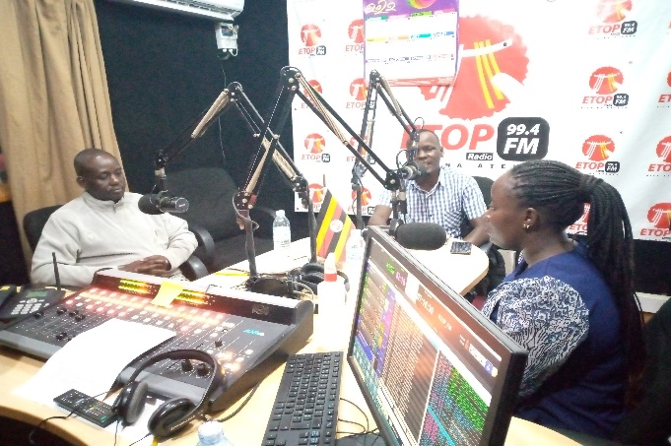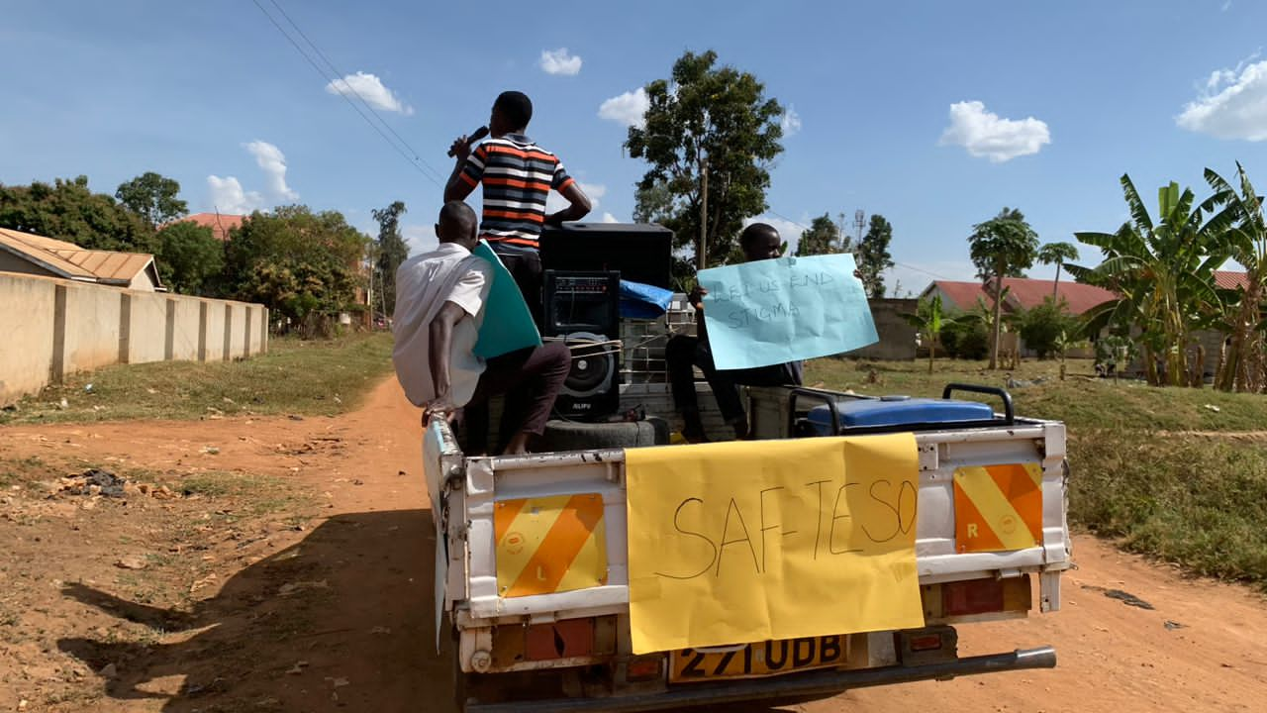

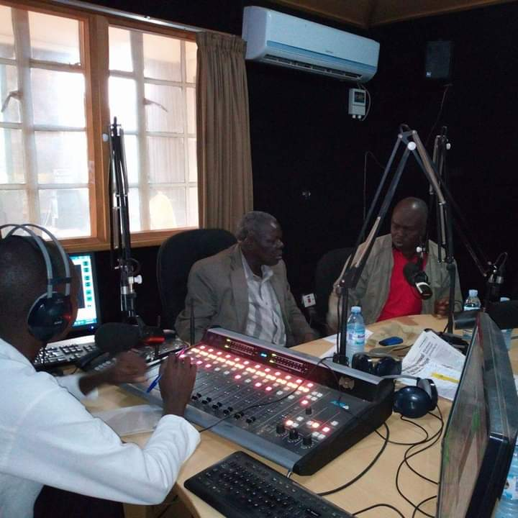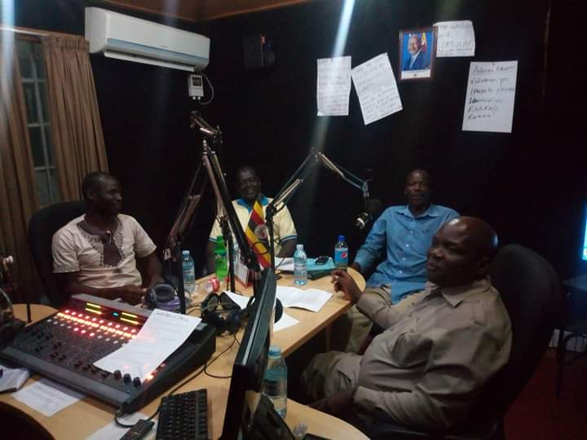

CHALLENGES
i. Health System Weaknesses: In some settings, weak health systems have posed a challenges to the effective implementation of HIV/TB prevention programs. For example, shortage of healthcare workers, and limited laboratory capacities has impeded timely diagnosis, treatment initiation, and monitoring of patients.
ii. Rising fuel cost that limited frequent movement to the field hence limiting the reach to far distance communities with a high burden of HIV/TB incidences.
iii. Access to Marginalized Populations: Reaching marginalized populations, such as people who inject drugs, sex workers, and transgender individuals, remains a challenge due to various factors, including social marginalization, criminalization, and limited access to healthcare. Tailored strategies and community-led approaches are required to engage these populations effectively.
iv. SAF-TESO supported a few health facilities hence there is need to scale-up HIV/TB program to more health centers located in catchment area with high burden of HIV/TB incidences in the Teso sub-region.

